How to copy CITL template (Compass 2g)

- Please follow the Compass Course Request documentation: http://go.citl.illinois.edu/CompassRequest, after step 10 number 2 please follow our instructions below.
- When you get to the “Search for Course Content” page under the section “Search for Courses to Copy” click the “Advanced Search” button.
- In the “Title” field enter: CITL Compass Template - 2019
- In the “Space Type” drop down, select “Development Space”
- Click on the Search button.
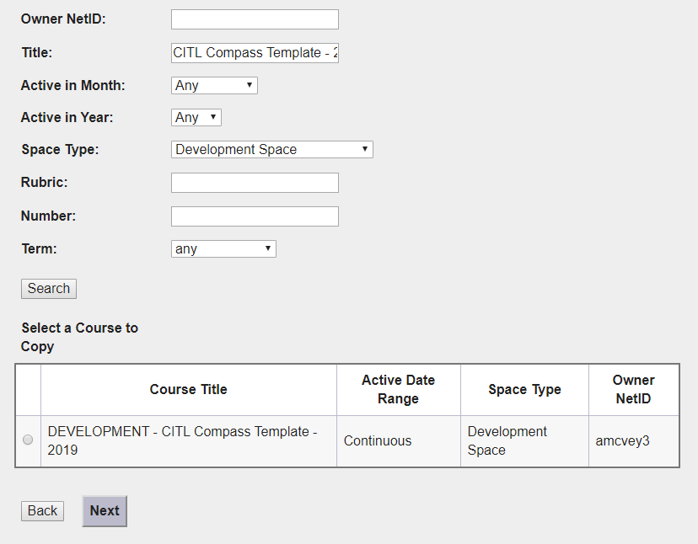
- Click the radio button to the left of the course that is displayed.
- Click the Next button
- If you should have any questions or problems please contact consult@illinois.edu

