How to copy CITL template (Moodle)

- Please follow the Moodle Requesting a Course Site documentation: http://go.citl.illinois.edu/MoodleRequest , once you reach the step “Choose Source” please follow our documentation below.
- When you get to the step called “Choose Source” select “Load material from prior course”.
- On “Choose Preload Source” select “I want to load material from a previous Learn@illinois course site.”.
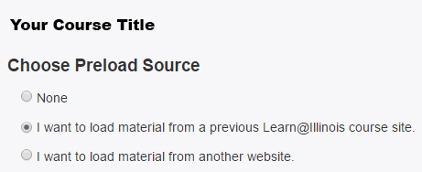
- Scroll to the bottom of the page and select the check box next to “Show courses from another instructor”.
- Enter in the NetID “mkk” and click on “Kage, Mitch” and then click the “Search” button.
- Hold the “ctrl” button and click “f” (or command + f for Mac users) to bring up the search feature in your browser. Enter “CITL Moodle Template – Master” and click enter. This will highlight the CITL template course that you will copy.
- Click the radio button to the left of “CITL Moodle Template – Master”.
- Scroll to the bottom of the page and click the green button “Save and continue”.

If you should have any questions or problems please contact ATLAS-tlt@illinois.edu

